Isabella Boone

Andrew Januszko

Dr. Carol Wellington

SWE 400, 01

9 November 2020

Transfer Rates to European Countries Using CORBA

# ***Abstract***

This research paper investigates the difference in transfer speeds from two servers located in Germany and Spain to a server in the United States. The transfers are measured using Java system time and handled by CORBA. The sample data used include 1, 2, 5, 10, 25, 50, and 100 Megabyte files. Data collected from these transfers state that Spain is the overall faster server, which becomes apparent as the file size increases.

# ***Introduction***

Common Request Object Broker Architecture, CORBA, is an architecture that allows the distribution of software across the internet. Through the use of object brokers, a connection between the client and server objects can be initiated, making it feel like the client is talking directly to the server. CORBA handles the transfers from the servers to the client in the United States.

The sample data used include 1, 2, 5, 10, 25, 50, and 100 Megabyte files. Each file runs 30 times, providing enough data to set a mean and standard deviation. Each server experiences one run per day over the course of 5 days.

Transfer times to the client would be faster from Spain when compared to Germany, as Spain is geographically closer to the United States. These transfers occurred from October 26th to October 30th at 8 PM. The sample files and the start times set the baseline, making the independent variable the server. Transfer times are stored in a CSV file, which is created by Java at runtime.

# ***Methods***

Before conducting this experiment, download the materials for project three from GitLab. Then, set the command line Java Development Kit and Java Runtime Environment to Java 8. Next, create 1, 2, 5, 10, 25, 50, and 100 MB files and store them in the FileSystemServer/src folder. Finally, open FileSystemClient.java and add code to track the time that it takes for the system to return a file. The code modifications used for this experiment tracked the time it took to get a response, then logged it into a CSV file.

**Disclaimer: For accurate results, use an ethernet cable for an internet connection rather than Wi-Fi.**

To conduct this experiment, make a copy of the project and distribute it on each server. Then in one terminal pane, ssh -X into Clipper. In another terminal pane, ssh -X into either lsaremotede or lsaremotese. In the LSA server pane, run the commands to start the orb and the server. Note that the heap size may need to increase to 768 MB to run.

In Clipper, run the command to start the client. Java should automatically generate a CSV file and start logging times in it. The entire process takes about 40 minutes to complete. When the process completes, transfer the results into a Microsoft Excel document for processing and analysis. Repeat the experiment on both servers, and repeat over the course of five days. Record all results in a Microsoft Excel document.

# ***Results & Analysis***

| **Spain compared to Germany (P-Values); <5% confirms hypothesis** | | | | | | | |
| --- | --- | --- | --- | --- | --- | --- | --- |
| Day | 1MB | 2MB | 5MB | 10MB | 25MB | 50MB | 100MB |
| 1 | 0.30% | 0% | 0% | 0% | 0% | 0% | 32.20% |
| 2 | 0.01% | 0% | 0% | 0% | 0% | 0.01% | 0% |
| 3 | 23.20% | 2.36% | 0% | 0% | 0% | 0% | 0% |
| 4 | 0.05% | 0.00% | 0% | 0% | 58.88% | 0% | 0% |
| 5 | 100% | 0% | 0% | 0% | 0% | 0% | 0% |

***Figure #1***

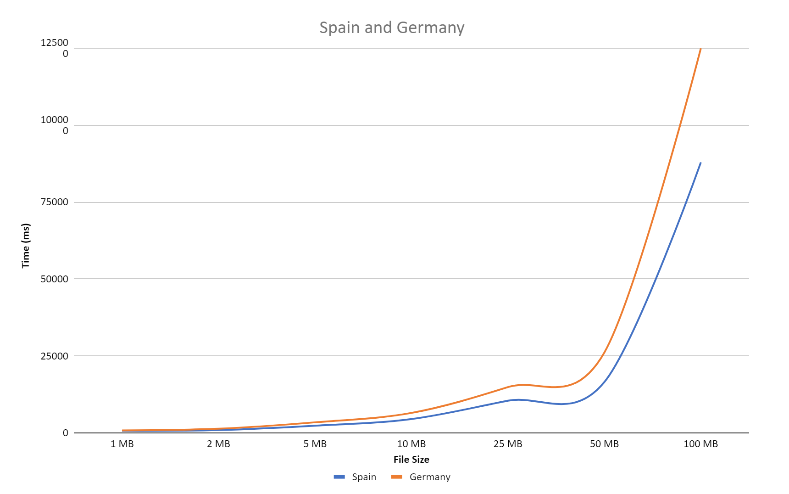

***Figure #2***

The chart seen in Figure #2 shows that Spain had lower transfer times when compared to Germany. The P-values in Figure #1 were calculated utilizing Minitab 2 Sample-t tests to verify that the information was valid. Although some P-values state that Spain and Germany should be equivalent; However, they could be ignored, as the days listed experienced higher transfer times overall. Note that on days three and five, Spain experienced higher transfer times compared to Germany. The higher transfer times could be due to load on the server or outside issues like internet tunnel switching or general high traffic.

# ***Conclusion & Further Research***

Based on the results produced above, the initial hypothesis can be supported, as the Spain server was faster than Germany. The use of an ethernet cable guaranteed that there was a hardwired connection to Clipper during the experiment. Further research into the topic would have a more diverse range of file sizes and types to see if a change in file types affects the transfer times for each server.